 | Name of Teaching Staff :- | Prof. Kantesh D C |  |  |  | 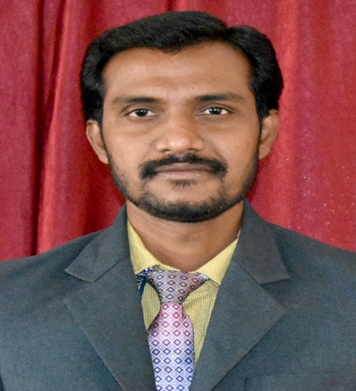
 | Designation :- | Assistant Professor
 | Department :- | Electrical & Electronics Engineering
 | Date of Joining the Institution:- | 16-08-2012
 | Qualifications with Class/Grade:- | UG |  | PG |  | Ph. D
 |  | B.E  (EEE) |  | M.Tech.  (Energy System Engineering)
 | Total Experience in Years:- | Teaching |  | Industry
 |  | 11 years |  | -----
Papers Published in Journals:- |  |  | National |  | International
 |  |  | 0 |  | 01
Conference Papers Published:- |  |  | National |  | International
 |  |  | 04 |  | 01
Ph.D Guide? Give field  University:- |  |  | Field |  | University
 |  |  | ----- |  | -----
Ph.Ds / Masters Level  Projects Guided:- |  |  | Ph. D. |  | Masters Level
 |  |  | ------ |  | --------
Books published / IPRs/ Patents:- |  |  | -----
Professional Memberships:- |  |  | -------
Consultancy Activities:- |  |  | -----
Awards:- |  |  | -----
Grants Fetched:- |  |  | KSCST
Interaction with Professional :-  Institutions |  |  | -----
Gmail |  |  | kantesh.dc@aitmbgm.ac.in
Google Scholar |  |  | https://scholar.google.com/citations?user=pVFCCd4AAAAJ&hl=en
Researchgate |  |  | https://www.researchgate.net/profile/Kantesh-Dc
Orcid Id |  |  | https://orcid.org/0000-0003-4579-9541

