 | Name of Teaching Staff :- | Dr Ramesh Bantwal |  |  |  | 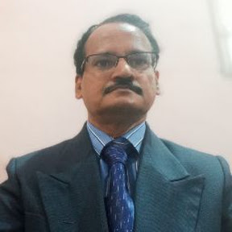
 | Designation :- | Professor
 | Department :- | Electrical & Electronics Engineering
 | Date of Joining the Institution:- | 22-07-2025
 | Qualifications with Class/Grade:- | UG |  | PG |  | Ph. D
 |  | B.E  (EE)  71.5% |  | M.E.  (Control & Instrumentation)  75.1% |  | Completed
 | Total Experience in Years:- | Teaching |  | Industry
 |  | 30 years |  | 00
Papers Published in Journals:- |  |  | National |  | International
 |  |  | 0 |  | 04
Conference Papers Published:- |  |  | National |  | International
 |  |  | 01 |  | 03
Ph.D Guide? Give field  University:- |  |  | Field |  | University
 |  |  | ----- |  | -----
Ph.Ds / Masters Level  Projects Guided:- |  |  | Ph. D. |  | Masters Level
 |  |  | ------ |  | 02
Books published / IPRs/ Patents:- |  |  | 03/01/0
Professional Memberships:- |  |  | ISTE (LM7708)  MIE (I) M-162568-8
Consultancy Activities:- |  |  | -----
Awards:- |  |  | -----
Grants Fetched:- |  |  | Tata Sponsored Project
Interaction with Professional :-  Institutions |  |  | -----
Gmail |  |  | rbantg5@gmail.com
Google Scholar |  |  | https://scholar.google.com/citations?hl=en&user=ySDYbqwAAAAJ
Researchgate |  |  | ----
Orcid Id |  |  | 0000-0002-7605-4449

